Section A:

- Match each quantity below with the correct units.

Concentration |  | g/dm³
Mass |  | dm³
Volume |  | g
Amount of substance |  | mol
 |  | mol/dm³

- Which of these is the correct definition of concentration?
Tick one box.
The amount of solute per unit volume of solvent
The amount of space a solution takes up
The amount of substance in a solution

- Which is the correct function of an indicator in a titration?
Tick one box.
To measure the concentration of an unknown reactant
To signify the end point of a reaction
To speed up the rate of reaction

- Label the following pieces of apparatus that are involved in a titration.
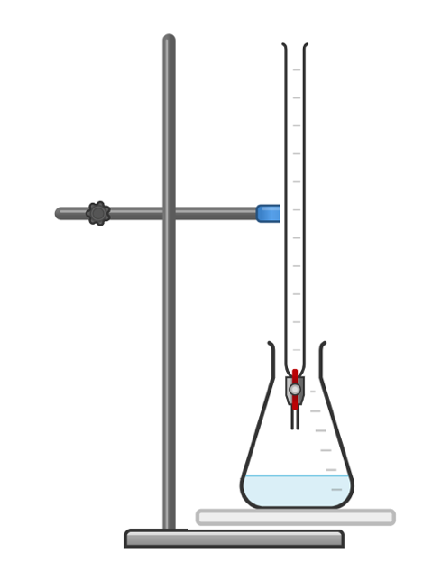

Section B

- A student is investigating the concentration of a sample of sodium hydroxide solution using titration. They use citric acid solution as the acid and phenolphthalein as the indicator.
  - Explain why phenolphthalein is used rather than Universal Indicator.

____________________________________________________________________________________
____________________________________________________________________________________
____________________________________________________________________________________

The equation for the reaction is:

3 NaOH + C₆H₈O₇ C₆H₅O₇Na₃ + 3 H₂O

  - Identify the chemical formula for citric acid.

____________________________________________________________________________________

  - The student required 12.5 cm³ of 0.1 mol/dm³ citric acid to neutralise 20 cm³ of sodium hydroxide solution.
Calculate the concentration of the sodium hydroxide solution in mol/dm³.

____________________________________________________________________________________
____________________________________________________________________________________
____________________________________________________________________________________
____________________________________________________________________________________
____________________________________________________________________________________
____________________________________________________________________________________

  - Explain how the student could make their results more reliable.

____________________________________________________________________________________
____________________________________________________________________________________
____________________________________________________________________________________

- Another student uses a similar method to find the concentration of an unknown citric acid solution using 25 cm³ of sodium hydroxide. The equation for the reaction is:

3 NaOH + C₆H₈O₇ C₆H₅O₇Na₃ + 3 H₂O

The table below shows the student’s results.

Titration | 1 | 2 | 3 | 4 | 5
Volume of citric acid solution (cm³) | 12.50 | 12.15 | 11.75 | 12.10 | 12.10

- State the word used to describe the volume of citric acid.

____________________________________________________________________________________

- 3 of these results are concordant. Explain what is meant by concordant results.

____________________________________________________________________________________
____________________________________________________________________________________
____________________________________________________________________________________

- Use the concordant results to calculate the mean volume of citric acid required. Write your answer to 2 decimal places.

____________________________________________________________________________________
____________________________________________________________________________________
____________________________________________________________________________________

- The concentration of sodium hydroxide was 0.15 mol/dm³. Calculate the concentration of citric acid solution. Write your answer to 2 significant figures.

____________________________________________________________________________________
____________________________________________________________________________________
____________________________________________________________________________________
____________________________________________________________________________________
____________________________________________________________________________________
____________________________________________________________________________________

- A student carried out a titration to determine the concentration of a sulfuric acid sample. They found that 27.1 cm³ of sulfuric acid was needed to neutralise 25 cm³ of 0.1 mol/dm³ of sodium hydroxide.
The equation for the reaction is:

2 NaOH + H₂SO₄ Na₂SO₄ + 2 H₂O

- Calculate the concentration of the sulfuric acid sample.

____________________________________________________________________________________
____________________________________________________________________________________
____________________________________________________________________________________
____________________________________________________________________________________
____________________________________________________________________________________
____________________________________________________________________________________

- Calculate the mass of sodium hydroxide that would have been dissolved to produce 25 cm³ of 0.1 mol/dm³ solution.

____________________________________________________________________________________
____________________________________________________________________________________
____________________________________________________________________________________
____________________________________________________________________________________
____________________________________________________________________________________
____________________________________________________________________________________

Section C

- Scientists can use titration to determine the concentration of sulfuric acid in a sample of rainwater to provide evidence of acid rain.
  - Briefly describe a method that could be used to determine the concentration of sulfuric acid in a rainwater sample.
  - Describe how acid rain is formed.
  - Suggest some environmental impacts of acid rain.
  - One of the main causes of acid rain is the burning of fossil fuels. Explain what fossil fuels are.
  - Suggest why people continue to burn fossil fuels even though they are aware of the environmental consequences.

